**MCQ.**

**1. 4**

**2. 1,3,4,5**

**3. 2**

**4. 2**

**5. 1**

**6. 2**

**7. 2,3,4**

**8. 4**

**9. 4**

**10. 4**

**11. 2**

**12. 1,2,4**

**13. 1**

**14. 4**

**15. 2**

**16. 4**

**17. 1**

**18. 2**

**19. 3**

**20. 1**

**Section B - Admin Configuration**

Question no. 2

**Workflow Rule (5 Marks)**

If Amount > $10,000 send an email alert on opportunity **closed won (Stage field value)** to pgoyal@kloudrac.com and msharma@kloudrac.com

Created an email template

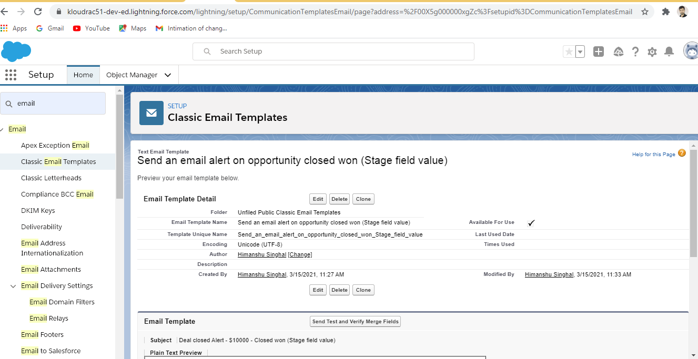

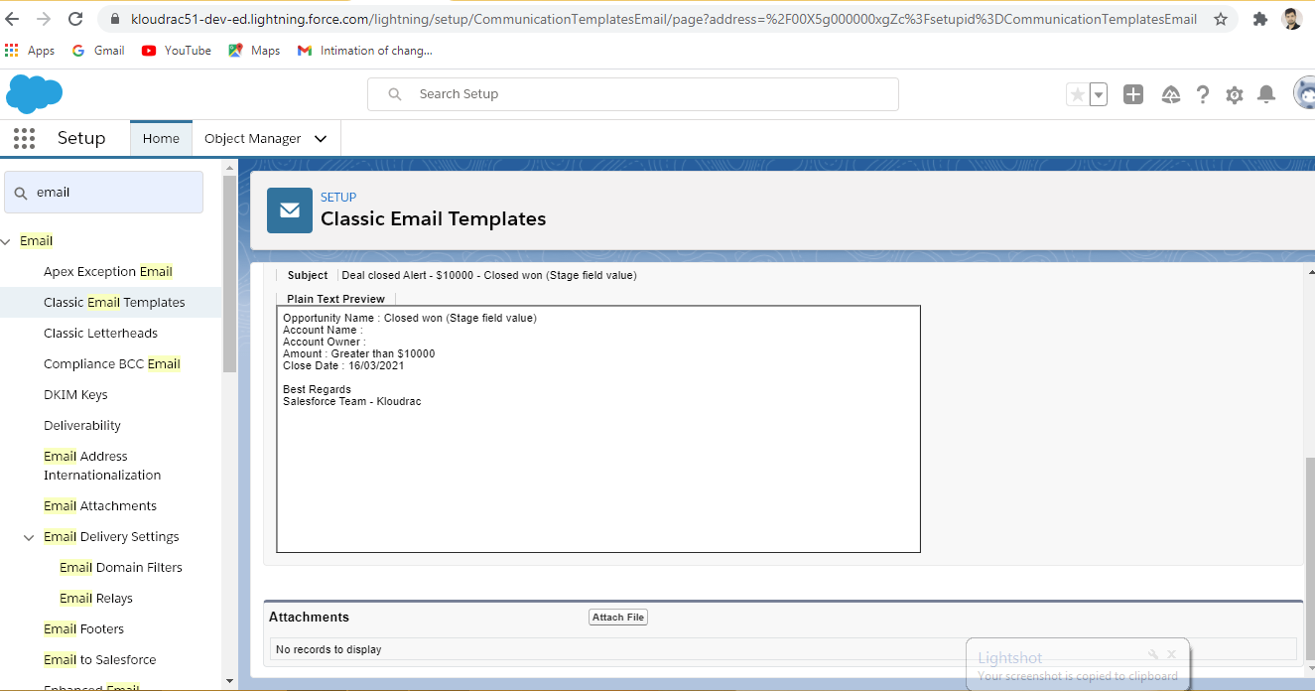

Created Workflow rules

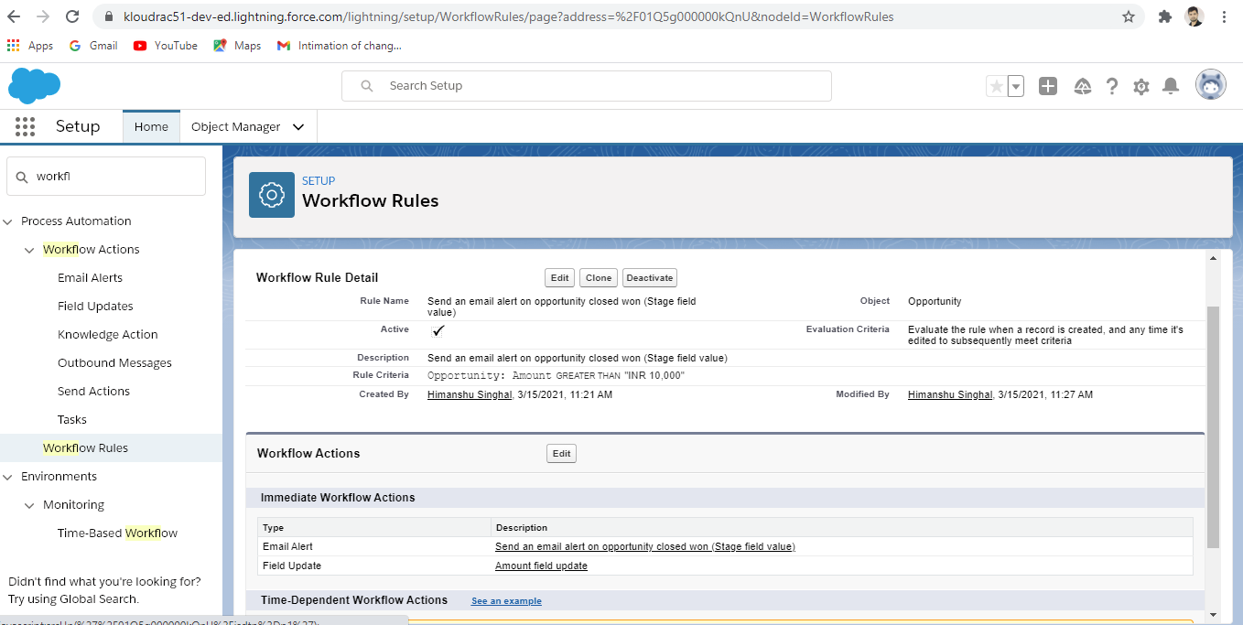

Created an object “Testing” with CLOSED WON Status and amount is $11000.

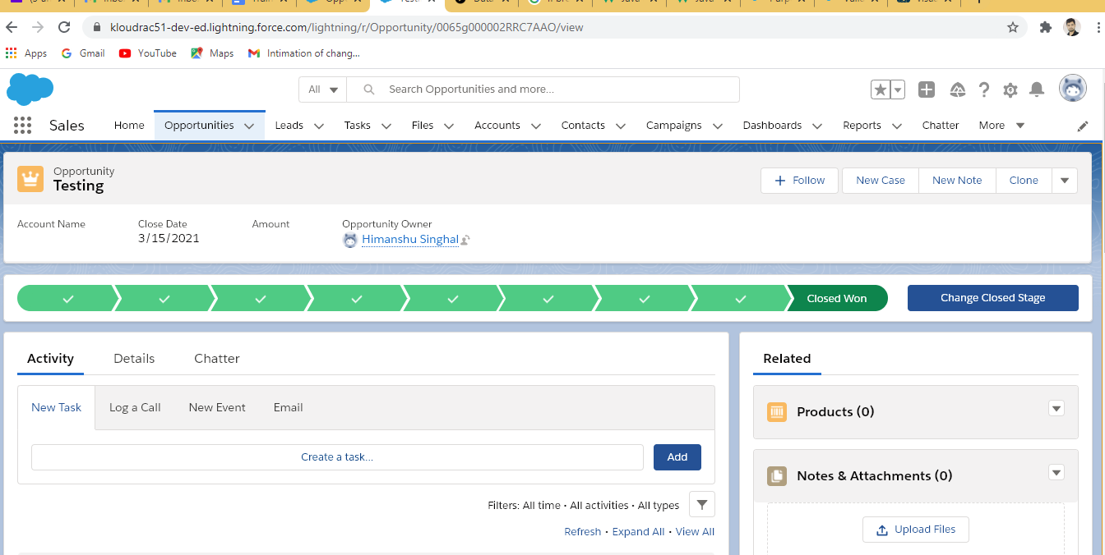

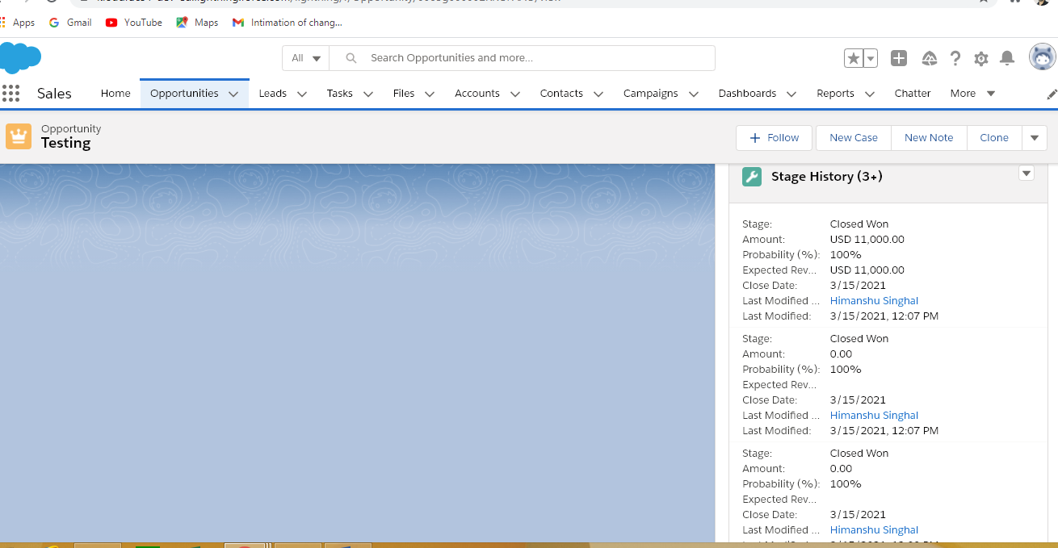

Question no. 1 (a)

1. **Validation Rules**

Only Admins should be allowed to change the account owner.

Error Message : "You are not authorised to transfer the account."

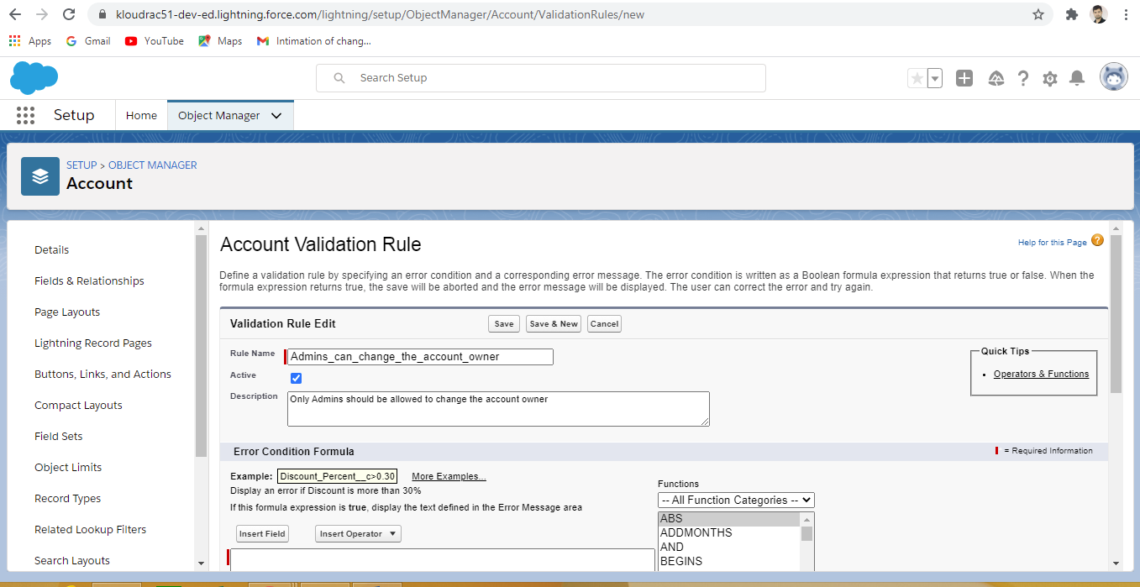

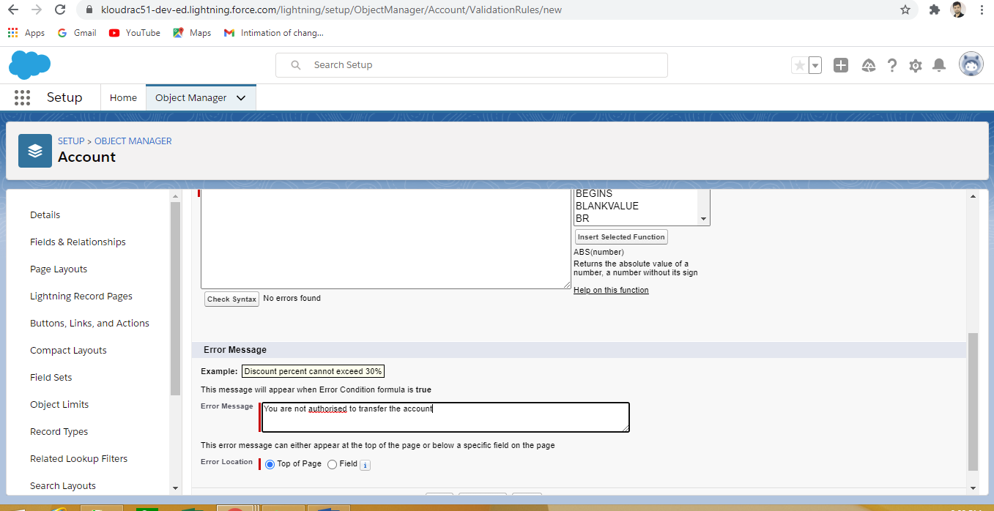

Question no. 3

1. **Process Builder (10 Marks)**

Kloudrac Softwares would like to set up a process where an event will get created on opportunity creation and an automated approval will go to the opportunity owner's manager whenever discount > 20% on opportunity.

There is a field Discount, Approval Status on Opportunity.

Default value for Discount - "Approval Not Required".

When Discount is greater than your allowed matrix - "Approval Required"

When submitted for approval - "Approval Pending"

When Approved / Rejected - "Approved / Rejected”

